**TIC TAC TOE**

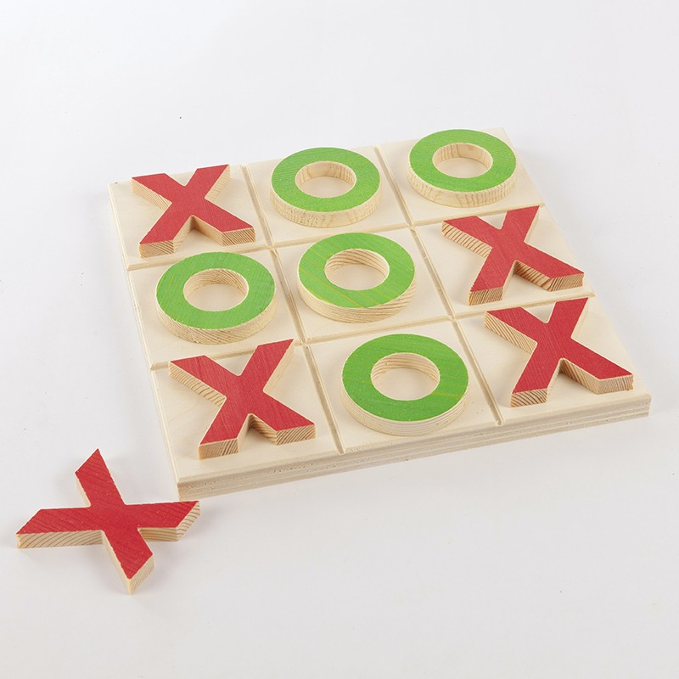

This tic tac toe has a variable size defined at the beginning, X and O have arbitrary values X=9999 and O=999. The user only have to enter xhere he wants to put is pawn.

**Function getPlace(matrix, place) :**

0 = (0,0) or 4 = (1,0)

|  |  |
| --- | --- |
| Element 1D | Element2D |
| 0 | (0,0) |
| 1 | (0, 1) |
| 2 | (0, 2) |
| 3 | (1, 0) |
| 4 | (1, 1) |
| 5 | (1, 2) |
| 6 | (2, 0) |
| 7 | (2, 1) |
| 8 | (2, 2) |

**Function transpose(matrix) :**

For example :

matrix=[['X','O','X'],['X','X','O'],['X','O','O']]

print(transpose(matrix)

will print : [['X', 'X', 'X'], ['O', 'X', 'O'], ['X', 'O', 'O']]

**Function sumOfDiagonals(element) :**

matrix=[[0,0,999],[0,999,0],[999,0,0]]

print : (999, 2997)

matrix=[[999,0,0],[0,999,0],[0,0,999]]

print : (2997, 999)

matrix = matrix=[[999,0,999],[0,999,0],[999,0,999]]

print : (2997, 2997)

the 0 in the last don’t have any consequences in the sum.

**Function verification(element) :**

matrix=[[999,0,0],[0,999,0],[0,0,999]]

SIZE=3

X=9999

O=999

return : 999 (O)

matrix=[[9999,0,0],[0,999,0],[0,0,9999]]

SIZE=3

X=9999

O=999

return 9999 (X)

matrix=[[1,0,0],[0,1,0],[0,0,1]]

SIZE=3

X=9999

O=999

return : -1